Adverb Phrase

✅ Definition:
# Source: AI Source: Provided by: [Data Path: Persons Table -> ID Column: 1, Name_En Column: Motasem Essam] -> From: [Chatgpt (GPT-4-turbo)] on [7/28/2025]
An adverb phrase is a group of words that functions as an adverb, meaning it modifies a verb, adjective, or another adverb. It provides information about how, when, where, why, or to what extent something happens.

🧩 Key Features of an Adverb Phrase:
# Source: AI Source: Provided by: [Data Path: Persons Table -> ID Column: 1, Name_En Column: Motasem Essam] -> From: [Chatgpt (GPT-4-turbo)] on [7/28/2025]
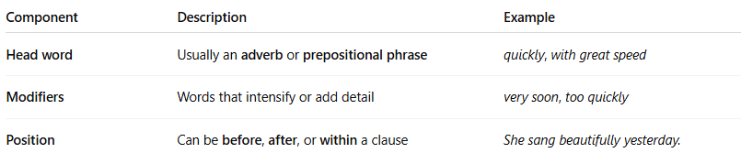
Component | Description | Example
Head word | Usually an adverb or prepositional phrase | quickly, with great speed
Modifiers | Words that intensify or add detail | very soon, too quickly
Position | Can be before, after, or within a clause | She sang beautifully yesterday.

✏️ Examples of Adverb Phrases:
# Source: AI Source: Provided by: [Data Path: Persons Table -> ID Column: 1, Name_En Column: Motasem Essam] -> From: [Chatgpt (GPT-4-turbo)] on [7/28/2025]
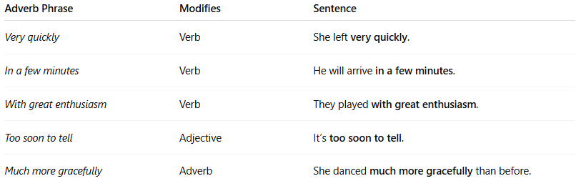
Adverb Phrase | Modifies | Sentence
Very quickly | Verb | She left very quickly.
In a few minutes | Verb | He will arrive in a few minutes.
With great enthusiasm | Verb | They played with great enthusiasm.
Too soon to tell | Adjective | It’s too soon to tell.
Much more gracefully | Adverb | She danced much more gracefully than before.

🧠 Common Uses of Adverb Phrases:
# Source: AI Source: Provided by: [Data Path: Persons Table -> ID Column: 1, Name_En Column: Motasem Essam] -> From: [Chatgpt (GPT-4-turbo)] on [7/28/2025]
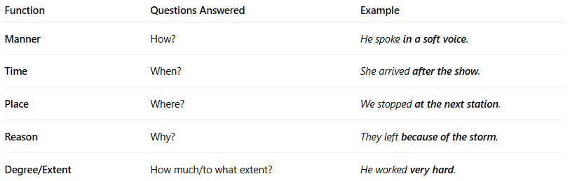

Function | Questions Answered | Example
Manner | How? | He spoke in a soft voice.
Time | When? | She arrived after the show.
Place | Where? | We stopped at the next station.
Reason | Why? | They left because of the storm.
Degree/Extent | How much/to what extent? | He worked very hard.

🔧 Adverb Phrase vs. Adverb (Single Word):
# Source: AI Source: Provided by: [Data Path: Persons Table -> ID Column: 1, Name_En Column: Motasem Essam] -> From: [Chatgpt (GPT-4-turbo)] on [7/28/2025]
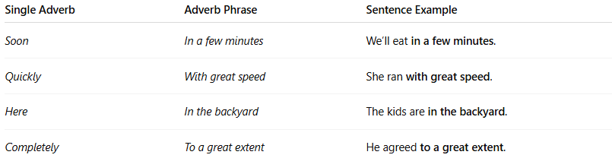

Single Adverb | Adverb Phrase | Sentence Example
Soon | In a few minutes | We’ll eat in a few minutes.
Quickly | With great speed | She ran with great speed.
Here | In the backyard | The kids are in the backyard.
Completely | To a great extent | He agreed to a great extent.

📌 Placement of Adverb Phrases:
# Source: AI Source: Provided by: [Data Path: Persons Table -> ID Column: 1, Name_En Column: Motasem Essam] -> From: [Chatgpt (GPT-4-turbo)] on [7/28/2025]
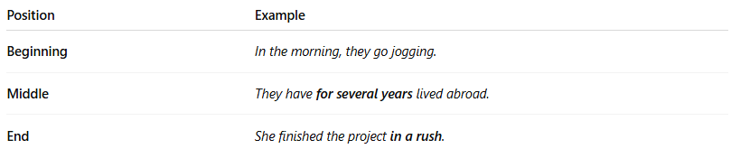

Position | Example
Beginning | In the morning, they go jogging.
Middle | They have for several years lived abroad.
End | She finished the project in a rush.

🧠 Summary Table:
# Source: AI Source: Provided by: [Data Path: Persons Table -> ID Column: 1, Name_En Column: Motasem Essam] -> From: [Chatgpt (GPT-4-turbo)] on [7/28/2025]
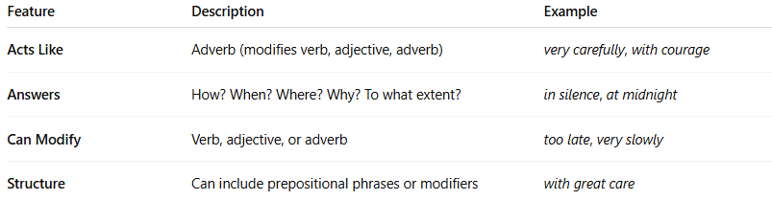

Feature | Description | Example
Acts Like | Adverb (modifies verb, adjective, adverb) | very carefully, with courage
Answers | How? When? Where? Why? To what extent? | in silence, at midnight
Can Modify | Verb, adjective, or adverb | too late, very slowly
Structure | Can include prepositional phrases or modifiers | with great care

